VTC6 Battery Cell Testing Project Outline

What is the purpose of the project?

The goal of this project is to obtain a greater understanding of the VTC6 cells used by our team for our battery pack. The battery data sheets are not guaranteed to be accurate to the batch of cells we received. Additionally the sheets do not contain all of the data we need for our goals.

The vehicle dynamics team is the primary beneficiary of the project, as the project arose from a need for more accurate, project specific data for battery modeling. Once all of the data is collected, vehicle dynamics will be able to accurately model the behavior of the pack in dynamics simulations in programs like CarSim.

How does CarSim model an EV powertrain?

Motor and generator calculations:
The motor of the power train is controlled by a torque request ($T_{cmd}$) demanded by the driver, which is given by a throttle position to power output curve. The program determines the available torque that is able to be given by the motor using a torque acceleration ($Ṫ$) and efficiency (E) equation.

$Ṫ=\frac{sign[min[f_{T}(ω),|T_{cmd}|\},T_{cmd}]-T}{t_{C}}$
Note: $t_{C}$ is a variable that denotes the time constant, and $ω$ is the rotational speed of the motor.
$E=f_{E}(T,ω)$
Note: E is calculated using a lookup table defined by the user.

The battery and electric circuit voltage, current and resistance is calculated based on the power required by the motor and generator. CarSim views an electric motor acting as a generator as a separate unit, so it's talking about the same component with a different name.

$P_{bttry }=P_{motor}+P_{gnrtr}$

Battery calculations:
The open-circuit voltage of the battery is calculated by a user defined lookup table function using battery temperature and SOC.

$V_{oc}=N_{bttry}×f_{voc}(temp,soc)$
Note:$N_{bttry}$ is the variable denoting the number of cells, acting as a gain for the per cell voltage.

The resistance (R) is calculated differently depending on if the cells are being charged or discharged, using different lookup functions that must be defined by the user.

$R=N_{bttry}×f_{R dis}(temp,soc), (P_{bttry}≥0, discharge)$
$R=N_{bttry}×f_{R chr}(temp,soc), (P_{bttry}<0, charge)$

The battery power is limited during both states, where the discharge power limit is defined by:

$V_{limit}=max(V_{OC}/2,V_{m min}, V_{bttry min}×N_{bttry})$

$P_{btr Ds}=\frac{(V_{OC}- V_{limit}) × V_{limit}}{R}-0.1$

Note: 0.1 is subtracted from the battery discharge power due to “modelers experience” according to CarSim, I assume this helps with correlation.

Next, battery charged power limit is calculated using the following:

$V_{btr ch}=\frac{(V_{OC}-V_{bttry max}*N_{bttry})×V_{bttry max}×N_{bttry}}{R}$

The battery power limit is thus determined using the calculated discharge power limit and battery power:

$P_{limit}=min(P_{bttry,}P_{btr Ds})$

The battery current is determined by one of two equations, whichever has the largest resultant value being used.

$A_{bttry}=\frac{V_{OC}-\sqrt{{V_{OC}}^{2}-4P_{limit}×R}}{2R}$

$A_{bttry}=\frac{V_{OC}-V_{bttry max}×N_{bttry}}{R}$

Thus, the battery output voltage is calculated as:

$V_{bttry}=V_{OC}-A_{bttry}×R$

Lastly, CarSim will calculate the SOC of the battery. The discharged capacity is derived via integration of the current. The unit of discharged capacity is to A-h by division by 3600.

$C_{btr Ds}=\frac{\int{}A_{bttry}dt}{3600}$

The battery SOC is calculated by the following:

$soc=\frac{(C_{max}-{C_{btr DS}}_{})}{C_{max}}$

The maximum capacity of the battery ${(C}_{max}$) is calculated using a user defined lookup table that references battery temperature.

Lastly the battery efficiency calculated easily using:

$E_{bttry}=\frac{V_{bttry}}{V_{OC}}$

Which information does the team need to model the battery in CarSim?

To model our battery pack, which uses VTC6 cells in a 138s5p configuration, we need the following data:

- Battery cell resistance as a function of SOC and cell temperature.
  - Pictures from an example data set:
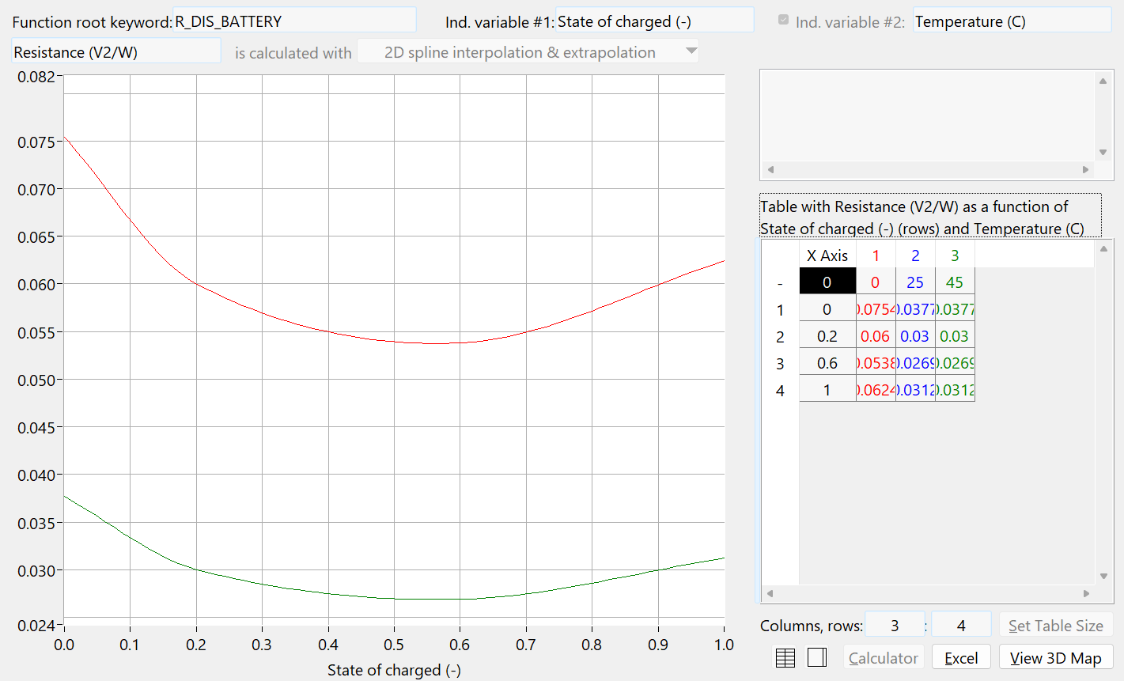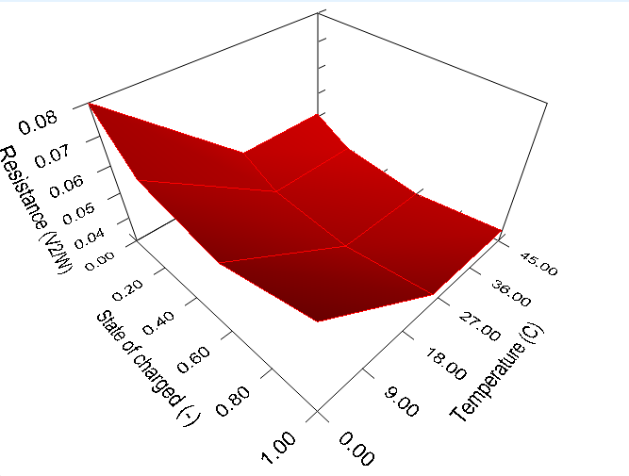
  - One function for discharging, and one for charging is needed.

- Open circuit voltage as a function of SOC and cell temperature.
  - Pictures of an example data set:
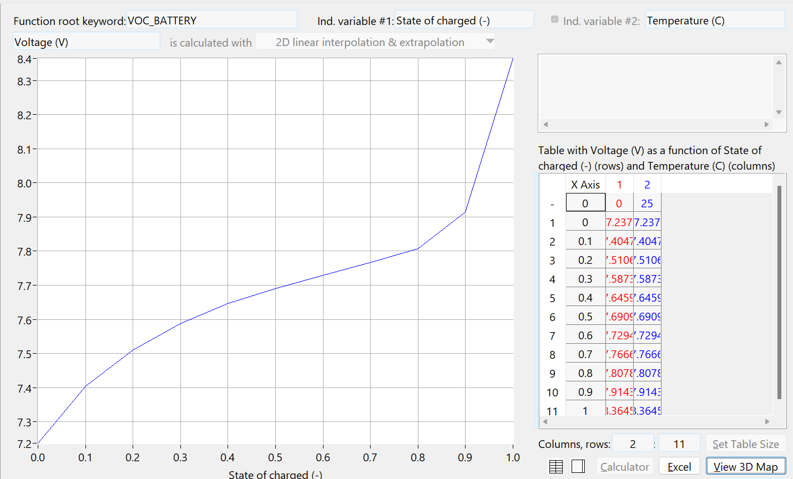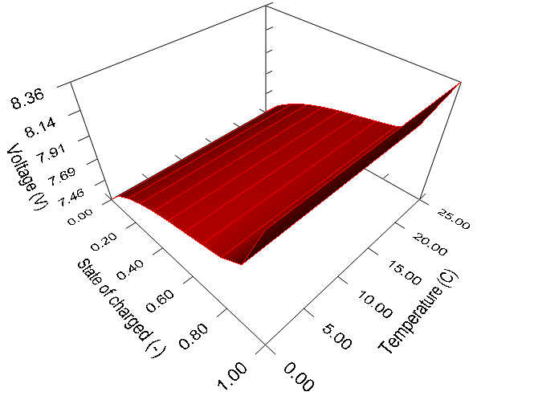
- Battery cell maximum capacity as a function of temperature.

